SUMMER TRAINING REPORT

ON

**HOSPITAL WEBSITE (Web development and DBMS)**

SUBMITTED IN PARTIAL FULFILLMENT OF THE REQUIREMENT FOR THE AWARD

OF THE DEGREE OF

**BACHELOR OF ENGINEERING**

(Computer Science & Engineering)



JUNE-JULY,2021

**SUBMITTED BY:**

NAME : **ABHISHEK SINGH**

UNIVERSITY UID : **20BCS4891**

DEPARTMENT OF COMPUTER SCIENCE & ENGINEERING

CHANDIGARH UNIVERSITY GHARUAN, MOHALI

**CHANDIGARH UNIVERSITY,GHARUAN,MOHALI**

**CANDIDATE'S DECLARATION**

I “**ABHISHEK SINGH**” hereby declare that I have undertaken Summer Training and developed project titled **HOSPITAL WEBSITE** during a period from **14th JUNE,2021 to** **10th JULY,2021** in partial fulfillment of requirements for the award of degree of B.E (COMPUTER SCIENCE & ENGINEERING) at CHANDIGARH UNIVERSITY GHARUAN, MOHALI. The work which is being presented in the training report submitted to Department of Computer Science & Engineering at CHANDIGARH UNIVERSITY GHARUAN, MOHALI is an authentic record of training work.

**ABHISHEK SINGH**

Signature of the Student

The training Viva–Voce Examination of__________________ has been held on ____________ and accepted.

Signature of Internal Examiner Signature of External Examiner

# Abstract

Today's web-based technology offers many online services in almost every field. Every major industry is converting and establishing a digital front for all their major operations to get closer to the booming digital market. In today's world the information flow is very fast and redundant means won't add to the betterment of the individual or the organization that's using them. Online connectivity is now a must for all the well organized and well managed establishments. One such field is Healthcare where the digitization of information should happen rapidly and efficiently. This paper addresses that particular region and paves a way for the creation of a software or website that help to make easy for the patient to book an appointment from Anyware, any time. These will help the people who are coming from long distances for the treatment. By these they can book and appointment with particular doctor they want to meet. Also, there data will be store in a hospital management system automatically and these will help them to Analyse record how many times and when they visit in hospital and also, they can store their proper treatment data in the website hence it will beneficial for them to manage their hospital records online rather than making and file or hard copy. Hence record can be store permanently for many year.

# Acknowledgement

While I was preparing this project report, various information that I found helped me in these projects and I am glad that I was able to complete this project and understand many things. Through preparation of this project (hospital website) was an immense learning experience and I inculcated many personal qualities during this process like responsibility, punctuality, confidence and others.

I would like to thank to my teachers who supported me all the time, cleared my doubts, who also played a big role in finalization of my project file. I am taking this opportunity to acknowledge their support and I wish that they keep supporting me like this in the future.

A project is a bridge between theoretical and practical learning and with this thinking I worked on the project and made it successful due to timely support and efforts of all who helped me.

Once again, I would like to thank my team mate and my friends also for their encouragement and help in designing and making these project creative. I am in debt of all these. Only because of my team mate we have able to complete these projects successfully by adding creative touches.

# About the Course/Company/ Industry / Institute



* The name of the university is inspired by The City Beautiful – Chandigarh, known as the epitome of cultural heritage and urbanization.
* Chandigarh University offers a unique and inspirational academic model designed to match the international standards. A wide spectrum of programs is paired with flexibility, experiential learning and interdisciplinary orientation.
* CU is involved in world-class research, with outstanding results in the contemporary research excellence framework.
* The University has a dynamic academic fraternity drawn from top universities nationally and internationally. CU offers the most conducive student-faculty ratio of 14:1, leading to 85 per cent student satisfaction.
* Chandigarh University provides a global perspective to facilitate the students with international learning opportunities, through partnerships with more than 306+ top-ranked universities worldwide.

# 1) INTRODUCTION

**1.1** During the time of pandemic we notice that the hospital where full of covid patient in such condition, it was very difficult for the people who have other problem to book an appointment with doctors. For that they need to visit hospital and then wait for hours for their number in hospital. in between people who may have an infection. So , it seems to be very risky for them to visit a hospital for their treatment. And also, some hospitals had closed the general OPD for the patients. By considering all these things we decide to make and project of hospital website form where any one and book an appointment with and doctor they want at any time and from anywhere.

**1.2** Our project report is on "Hospital Website". In this website, we are giving detailed information about the hospital and its operations. The website is designed in an interactive manner and is able to give the users the knowledge of the expertise, experience and hospitality of the hospital. Through this website patients can get information not only about the expertise field but also the eminence of the hospital. The patients would be able to get daily updates of their queries and they can go through the profiles of the doctors. All the departments of the hospital have senior and experienced heads and the website gives all the necessary information about them. The website consists of webpage giving information about the appointment availability, latest updates and news of hospital. The events held by the hospital are showcased in a different section of the website giving it a communicative view. This website also consists of hyperlinks such as rules and regulations, contact us and so on. From these hyperlinks, we can get to know what are the rules and regulations of the hospital and patient's feedback about the information that they acquire from the website and they can also comment and express their views on it. Our website also helps to connect the common people with the hospital and they can now get to know each and everything about the hospital and can book appointments with doctors. A different section has been provided for contacting the hospital for any queries.

**1.3** These website will provide and interface to a user from which they can select the particular department in which

**1.4** They need treatment and want to meet a doctor department,neurology,nephrology,orthopedic,cardiology,eye- care,dentist,general). Here they will find and list of doctors for each department with their basic data hence user can choose their doctor on their choice from whom they want to consult and then fill and appointment form to book and appointment that data will be store in local host and hence can visit hospital at particular time they have chosen.

**1.5** This project is based on web development and DBMS, these is consisting of mainly 4 languages (HTML, CSS, JAVA SCRIPT, MSQL). and software like vscode, xampp.

**1.6** In vscode software we have made an website using HTML,CSS and JAVA SCRIPT

**1.7** And by using xampp and phpMyAdmin we have stored the data filled in form in local database in backend

**PROBLEMS IN EXISTING SYSTEM**

1. Earlier the records were kept done manually which was highly time consuming and expensive.
2. There can be no interaction between the patients and doctors.
3. Patients used to stand in long queues.
4. Wastage of Stationary other material resources increase due to paper work.
5. Current manual system requires large efforts to compile information.
6. With the increase in data, the processes of maintaining, updating and storing of information are becoming difficult
7. Data extraction becomes difficult as one has to search among large pile of papers.

**OBJECTIVES OF PROPOSED SYSTEM:**

1. This system helps in lowering manual work done by the patients to get appointments of doctors in a single click. It helps in keeping the patients updated about the availability of doctors.

1. Nowadays, it has become easy to get information through websites. No newspaper, magazines and interviews etc are required because each and every information is easily available on the website.

1. It helps in reaching the information to large number of patients/visitors in minimum time. Modes of information is faster than the way before.

1. It can be the centralized source of information.

**2) TRAINING AND WORK UNDERTAKEN:**

**2.1** We have chosen a project from a project basket that have been shared with us and decided to make a hospital website.

**2.2** In our group 4 member are there and we divide our work equally in 4 parts.

**2.3** We have selected appropriate software tools to complete our project like vscode , xampp ,phpMyAdmin etc.

**2.4** Then we made a rough structure of our website decide every element cover every aspect and started working on project.

**2.5** we have used vscode software for making and designing website our website using HTML and CSS. The data in the website is inserted using html and animations and designing were given by css .

**2.6** I have made backend database to store data using xampp and phpmyadmin and done some other designing work of our project.

**2.7** Futher we have created a backend database using xampp and phpMyAdmin software tool which allow user to fill the data in the form and that data is stored in the local host for father access.

**2.8** We tried to keep our project user friendly and easy to use and understand with a limited knowledge we tried to cover every aspect of an website.

**2.9** We work well in the team and everybody had done their work with 100% efforts and given best output as result

**3) RESULTS AND DISCUSSION:**

**HOMEPAGE**

**HTML:**

<!DOCTYPE html>

<html lang="en">

<head>

    <meta charset="UTF-8">

    <meta http-equiv="X-UA-Compatible" content="IE=edge">

    <meta name="viewport" content="width=device-width, initial-scale=1.0">

    <link rel="stylesheet" href="home.css">

    <title>Home</title>

</head>

<body>

    <div>

        <img class="logo" src="image/vcare2.png" alt="went wrong" width="50px" height="50px">

    <ul class="nav-bar">

        <li><a class="home" href="#">Home</a> </li>

        <li class="dipart">Department

        <div class="sub-list">

            <ul>

                <li><a href="cardiology.html">Cardiologist</a></li>

                <li><a href="orthopedic.html">Orthopedic</a></li>

                <li><a href="neurology.html">Neurologists</a></li>

                <li><a href="nephrology.html">Nephrologists</a></li>

                <li><a href="dentist.html">densist</a></li>

                <li><a href="eyecare.html">Eye-care</a></li>

                <li><a href="genral.html">General</a></li>

            </ul>

        </div>

    </li>

    <li><a class="apoint" href="http://localhost/abhishekproject/project.php">Appointment</a></li>

    <li><a class="make" href="http://localhost/abhishekproject/feedback.php">Feedback</a></li>

    <li><a class="contact" href="#">Contact us</a></li>

    <li><a class="about" href="about.html">About</a></li>

    </ul>

</div>

<div class="homepage">

<h1 class="welcome">NEWLIFE HOSPITAL</h1>

<h3>"A LITTLE PROGRESS EACH DAY ADDS UP TO BIG RESULTS"</h3>

<img src="image/—Pngtree—doctors_914490.png" alt="wrong">

</div>

</body>

</html>

**CSS:**

*{

    padding: 0;

    margin: 0;

}

body{

        background-image: url("image/16333.jpg");

        background-position: center;

        position: relative;

        background-size: cover;

        background-attachment: fixed;

    }

ul{

    display:inline-flex;

    background-color:rgba(14, 47, 235, 0.897);

    list-style: none;

    color: white;

    font-weight: bold;

    width: 100%;

    border-radius: 2%;

    /* position:fixed; */

}

li{

    padding: 15px;

    margin: 2px;

}

ul.nav-bar a{

    color: white;

    font-family: cursive;

    text-decoration: none;

    font-weight: bold;

    font-size: 20px;

}

.dipart{

    color: white;

    font-family: cursive;

    text-decoration: none;

    font-weight: bold;

    font-size: 20px;

}

.dipart:hover{

    color: lawngreen;

    font-family: cursive;

    font-weight: bold;

    color: white;

    text-shadow: 0px 0px 30px rgb(0, 4, 255);

    font-size: 25px;

}

.dipart:hover .sub-list{

    display: block;

    position:absolute;

    padding: 1px;

    margin: 0;

}

.dipart:hover .sub-list ul{

    display: block;

    background-color: rgb(8, 8, 211);

}

.dipart:hover .sub-list ul li{

width: 150px;

background-position: center;

padding: 10px;

border-bottom: 1px dotted white;

background: transparent;

text-align: left;}

.dipart:hover .sub-list ul li:last-child{

    border-bottom: none;}

.dipart:hover .sub-list ul li:hover{

    color: rgb(3, 7, 255);}

div img.logo{

    position:absolute;

    left: 95%;

    border-radius: 50%;}

ul li div.sub-list{

display: none;}

.dipart:hover h1.welcome

{

display: none;

}

h1

{

    text-align: center;

    font-size: 70px;

    font-family: Arial;

    text-transform: uppercase;

    font-weight: bold;

    /* color: rgba(141, 12, 12, 0.438); */

    /* border: 2px solid lime; */

    width: 100%;

    height: 100%;

    position:absolute;

    left: 50%;

    top: 70%; transform: translate(-50%,-50%);

    width: 900px;

    height: 100px;

    background-color: rgba(0, 0, 0, 0);}

h1{

    -webkit-box-reflect:below 1px linear-gradient(transparent,rgba(75, 4, 4, 0.356)) ;

    line-height: 2em;

    outline: none;

    animation: animate 15s linear infinite;}

@keyframes animate{

    0%,18%,20%,50.1%,60%,65.1%,80%,90.1%,92%

    {

        color: rgb(47, 90, 190);

        text-shadow: none;

    }

    18%,1%,20.1%,30%,50%,60.1%,65%,80.1%,90%,92.1%,100%

    {

        color:white;

        text-shadow:0px 0px 10px rgb(3, 7, 255),

    0px 0px 20px rgb(3, 7, 255),

    0px 0px 40px rgb(3, 7, 255),

    0px 0px 80px rgb(3, 7, 255),

    0px 0px 160px rgb(3, 7, 255);

    }

}

h3

{

    text-align: center;

    font-size: 25px;

    font-family: cursive;

    font-weight: bold;

    color: rgb(255, 255, 255);

    /* border: 2px solid lime; */

    width: fit-content;

    position:absolute;

    left: 50%;

    top: 120%; transform: translate(-50%,-50%);

    width: 800px;

    height: 40px;

    text-shadow: 0px 0px 15px rgb(17, 0, 248);

    border: 2px double black;

    border-radius: 20px;

    background-color: rgba(0, 0, 0, 0.185);

}

ul.nav-bar a:hover{

    color: lime;

}

div.homepage img{

    height: 230px;

    width: 230px;

    margin: 30px;

}

**OUTPUT:**

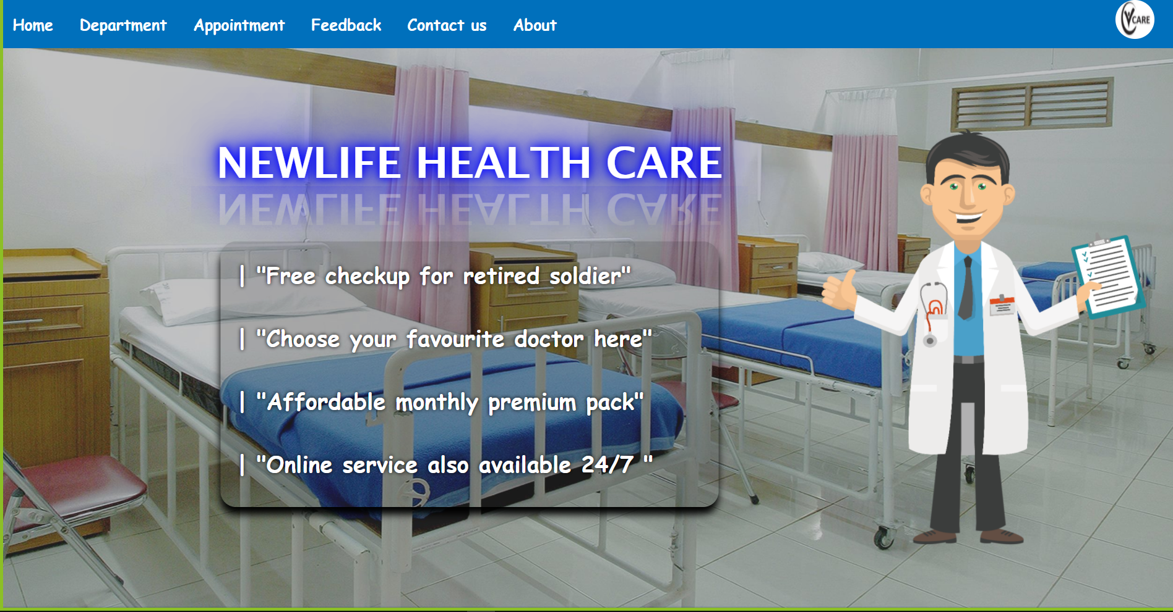

**APPOINTMENT**

**HTML:**

<?php

include("connect.php");

error_reporting(0);

?>

<!DOCTYPE html>

<html>

<head>

    <title>

        Appointment form

    </title>

    <link rel="stylesheet" href="apppp.css">

</head>

<body>

<div>

<img class="logo" src="image/vcare2.png" alt="went wrong" width="50px" height="50px">

<ul class="nav-bar">

<li><a class="home" href="home.html">Home</a> </li>

<li class="dipart">Department

<div class="sub-list">

    <ul>

                <li><a href="cardiology.html">Cardiologist</a></li>

                <li><a href="orthopedic.html">Orthopedic</a></li>

                <li><a href="neurology.html">Neurologists</a></li>

                <li><a href="nephrology.html">Nephrologists</a></li>

                <li><a href="dentist.html">densist</a></li>

                <li><a href="eyecare.html">Eye-care</a></li>

                <li><a href="genral.html">General</a></li>

    </ul>

</div>

</li>

<li><a class="apoint" href="http://localhost/abhishekproject/project.php">Appointment</a></li>

<li><a class="make" href="http://localhost/abhishekproject/feedback.php">Feedback</a></li>

<li><a class="contact" href="#">Contact us</a></li>

<li><a class="about" href="about.html">About</a></li>

</ul>

</div>

    <div class="container">

        <form>

            <h1 class="heading">APPOINTMENT FORM</h1>

            <fieldset class="contact">

                <legend>

            <h2>Contact details</h2>

        </legend>

            <P class="name"> Name : <input type="text" name="name" required placeholder="Enter your name"></P>

            <P class="number"> Mobile Number : <input type="number" name="number" required placeholder="Enter your mobile number"></P>

            <P class="gender"> Gender : <input type="text" name="gender" required placeholder="Enter your Gender"></P>

            <!-- <fieldset class="gender">

                <legend>

                    Gender

                </legend>

                <p class="gender">

                    male :<input type="radio" name="gender" id="male"required>

                    female :<input type="radio" name="gender" id="female"required>

                </p>

            </fieldset> -->

            <P class="address"> Address : <textarea name="address" id="address" cols="100" rows="10"required placeholder="Enter your address"></textarea> </P>

            <p class="email">Email : <input type="email" name="email" id="email"required placeholder="Enter your Email"></p>

            <p class="pincode">Pincode : <input type="number"name="pincode" id="pincode"required placeholder="Enter your pincode" ></p>

        </fieldset>

        <fieldset class="medical">

            <legend>

                <h2>

                    Medical-conditions

                </h2>

            </legend>

            <p class="problem">

                Describe problem : <textarea name="problem" id="address" cols="100" rows="10"required placeholder="Describe problem"></textarea>

            </p>

            <P class="doctor">

                Doctor name : <input type="text" name="doctor" id="doctor" required placeholder="Enter doctor's name">

            </P>

            <P class="date">

                Appointment date : <input type="date" name="date" id="date">

            </P>

        </fieldset>

        <p class="paynow">  <input type="submit" value="Submit"></p>

        </form>

    </div>

</body>

</html>

<?php

$an=$_GET['name'];

$bn=$_GET['number'];

$cn=$_GET['gender'];

$dn=$_GET['address'];

$en=$_GET['email'];

$fn=$_GET['pincode'];

$gn=$_GET['problem'];

$hn=$_GET['doctor'];

$in=$_GET['date'];

/*echo"$an";

echo"$bn";

echo"$cn";

echo"$dn";

echo"$en";

echo"$fn";

echo"$gn";

echo"$hn";

echo"$in";  */

$query="insert into patient values ('$an','$bn','$cn','$dn','$en','$fn','$gn','$hn','$in')";

$data=mysqli_query($conn,$query);

if($data){

    echo"";

}

else{

    echo"Failed";

}

?>

**CSS:**

*{

    box-sizing: border-box;

    margin: 0;

    padding: 0;

}

body{

    background-color: rgb(141, 229, 245);

    font-family: Arial;

    font-weight: bold;

    font-size: 17px;

}

.container{

    background-color: orange;

    border:5px solid rgb(255, 0, 0);

    padding: 8px;

    width: 70%;

    margin: 10px 18%;

    border-radius: 5px;

    border-radius: 5px;

    box-shadow: 10px 10px 15px black;

}

input[type="text"],

input[type="number"],

input[type="radio"],

input[type="email"],

input[type="date"],

select,textarea{

    padding: 10px;

    width: 100%;

    border: 2px solid black;

    border-radius: 5px;

}

fieldset.contact{

    border-radius: 5px;

    background-color: blanchedalmond;

}

fieldset.medical{

    border-radius: 5px;

    background-color:blanchedalmond ;

    padding:10px ;

}

fieldset.gender{

    background-color: white;

    border: 2px solid black;

}

input[type="submit"]{

    width: 20%;

    background-color:lawngreen;

    padding: 10px;

    border-radius: 5px;

    font-size: 17px;

    text-align: center;

}

input[type="submit"]:hover{

    background-color: orangered;

    color: floralwhite;

}

h1.heading{

    text-align: center;

}

img.image{

height: 20px;

width: 200px;

}

input[type="number"]{

    border: 2px solid black;

    border-radius: 5px;

}

input[type="email"]{

    border: 2px solid black;

    border-radius: 5px;

}

input[type="date"]{

    width: 20%;

    padding: 5px;

}

h1.heading{

    color: rgb(3, 3, 116);

    /* text-shadow:0px 0px 20px #03bcf4; */

    text-transform: uppercase;

}

fieldset.contact h2{

    color: rgb(3, 3, 116);

    /* text-shadow:0px 0px 20px #03bcf4; */

    margin: 25px;

    text-transform: uppercase;

}

fieldset.gender{

    padding: 10px;

    margin: 5px;

}

fieldset.medical h2{

    color: rgb(3, 3, 116);

    /* text-shadow:0px 0px 20px #03bcf4; */

    text-transform: uppercase;

    margin: 10px;

    padding: 10px;

}

p.name{

    padding: 10px;

    margin: 5px;

}

p.number{

    padding: 10px;

    margin: 5px;

}

p.address{

    padding: 10px;

    margin: 5px;

}

p.email{

    padding: 10px;

    margin: 5px;

}

p.gender{

    padding: 10px;

    margin: 5px;

}

p.pincode{

    padding: 10px;

    margin: 5px;

}

p.problem{

    padding: 10px;

    margin: 5px;

}

p.doctor{

    padding: 10px;

    margin: 5px;

}

p.date{

    padding: 10px;

    margin: 5px;

}

input[type="submit"]{

    width: 20%;

    background-color:rgb(251, 196, 106);

    padding: 10px;

    margin: 10px 40%;

    border-radius: 5px;

    font-size: 17px;

    font-weight: bold;

    text-align: center;

}

ul{

    display:inline-flex;

    background-color:rgba(14, 47, 235, 0.897);

    list-style: none;

    color: white;

    font-weight: bold;

    width: 120%;

    border-radius: 2%;

    /* position:fixed; */

}

li{

    padding: 15px;

    margin: 2px;

}

ul.nav-bar a{

    color: white;

    font-family: cursive;

    text-decoration: none;

    font-weight: bold;

    font-size: 20px;

}

.dipart{

    color: white;

    font-family: cursive;

    text-decoration: none;

    font-weight: bold;

    font-size: 20px;

}

.dipart:hover{

    color: lawngreen;

    font-family: cursive;

    font-weight: bold;

    color: white;

    text-shadow: 0px 0px 30px rgb(0, 4, 255);

    font-size: 25px;

}

.dipart:hover .sub-list{

    display: block;

    position:absolute;

    padding: 1px;

    margin: 0;

}

.dipart:hover .sub-list ul{

    display: block;

    background-color: rgb(8, 8, 211);

}

.dipart:hover .sub-list ul li{

width: 150px;

background-position: center;

padding: 10px;

border-bottom: 1px dotted white;

background: transparent;

text-align: left;

}

.dipart:hover .sub-list ul li:last-child{

    border-bottom: none;

}

.dipart:hover .sub-list ul li:hover{

    color: rgb(3, 7, 255);

}

div img.logo{

    position:absolute;

    left: 95%;

    border-radius: 50%;

}

ul li div.sub-list{

display: none;

}

.dipart:hover h1.welcome{

display: none;

}

ul.nav-bar a:hover{

    color: lime;

}

div.homepage img{

    height: 230px;

    width: 230px;

    margin: 30px;

}

**OUTPUT:**

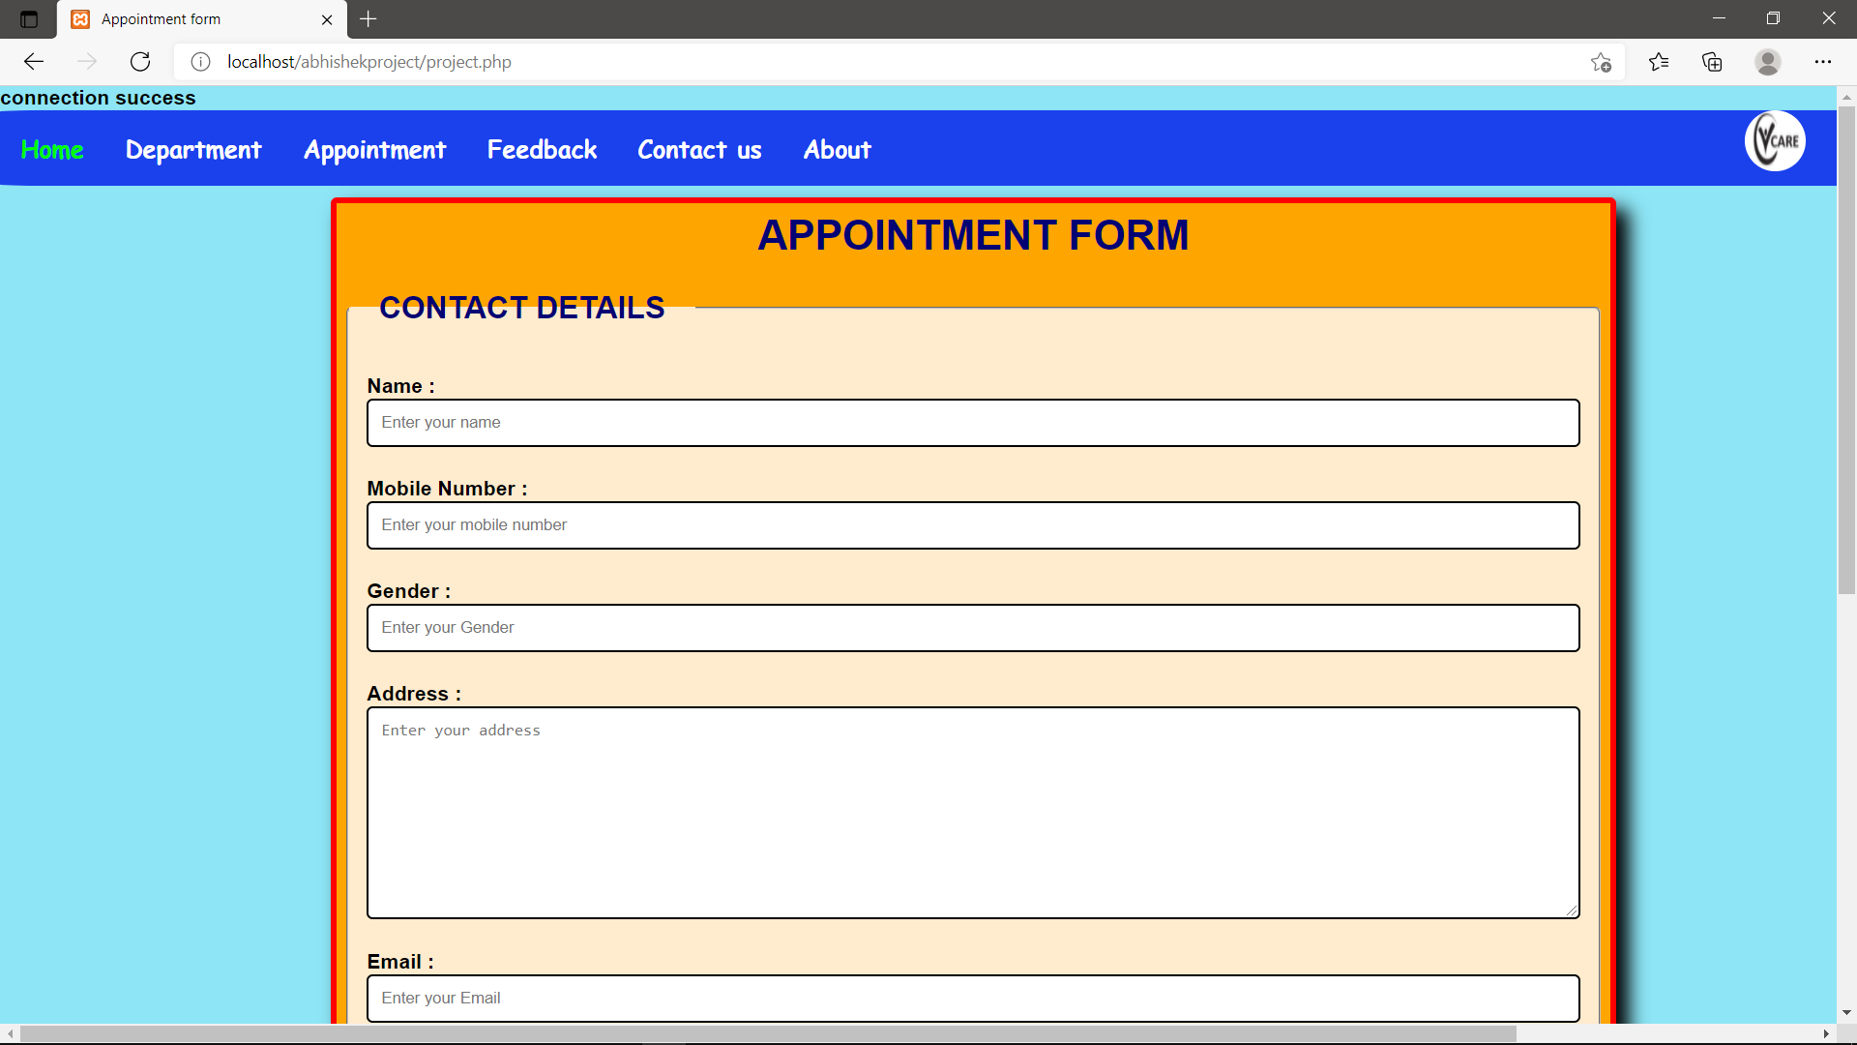

**FEEDBACK**

**HTML:**

<?php

include("feedconnect.php");

error_reporting(0);

?>

<!DOCTYPE html>

<html lang="en">

<head>

    <meta charset="UTF-8">

    <meta http-equiv="X-UA-Compatible" content="IE=edge">

    <meta name="viewport" content="width=device-width, initial-scale=1.0">

    <title>Feedback</title>

    <link rel="stylesheet" href="feedbac.css">

</head>

<body>

    <div>

        <img class="logo" src="image/vcare2.png" alt="went wrong" width="50px" height="50px">

    <ul class="nav-bar">

        <li><a class="home" href="home.html">Home</a> </li>

        <li class="dipart">Department

        <div class="sub-list">

            <ul>

                <li><a href="cardiology.html">Cardiologist</a></li>

                <li><a href="orthopedic.html">Orthopedic</a></li>

                <li><a href="neurology.html">Neurologists</a></li>

                <li><a href="nephrology.html">Nephrologists</a></li>

                <li><a href="dentist.html">densist</a></li>

                <li><a href="eyecare.html">Eye-care</a></li>

                <li><a href="genral.html">General</a></li>

            </ul>

        </div>

    </li>

    <li><a class="apoint" href="http://localhost/abhishekproject/project.php">Appointment</a></li>

    <li><a class="make" href="http://localhost/abhishekproject/feedback.php">Feedback</a></li>

    <li><a class="contact" href="#">Contact us</a></li>

    <li><a class="about" href="about.html">About</a></li>

    </ul>

</div>

    <div class="container">

        <form>

            <div>

            <h1 class="heading">Feedback</h1>

        </div>

           <p class="name"> Name : <input type="text" name="name" required placeholder="Enter full name"> </p>

           <p class="number">Mobile number : <input type="number" name="number" width="90px" required placeholder="Enter mobile number"></p>

           <p class="email">Email : <input type="email" name="email" id="email"></p>

           <p class="department">Department : <input type="text" name="department" required placeholder="Enter department name"></p>

               <!-- <select name="department" id="department" required>

                <option value="">--------------------------------------------------Select Department-----------------------------------------------------</option>

               </select>

           </p> -->

           <p class="message">

               Message : <textarea name="message" id="message" cols="80" rows="10"></textarea>

           </p>

           <p class="submit">

               <input type="submit" name="SUBMIT" value="Submit">

           </p>

        </form>

    </div>

</body>

</html>

<?php

$ln=$_GET['name'];

$mn=$_GET['number'];

$nn=$_GET['email'];

$on=$_GET['department'];

$pn=$_GET['message'];

/*echo"$an";

echo"$bn";

echo"$cn";

echo"$dn";

echo"$en";

echo"$fn";

echo"$gn";

echo"$hn";

echo"$in";  */

$query="insert into feedback values ('$ln','$mn','$nn','$on','$pn')";

$data=mysqli_query($conn,$query);

if($data){

    echo"";

}

else{

    echo"Failed";

}

?>

**CSS:**

*{

    box-sizing: border-box;

    margin: 0%;

    padding: 0%;

}

body{

    background-color: rgb(141, 229, 245);

    font-family: Arial;

    font-weight: bold;

    font-size: 17px;

}

.container{

    background-color: blanchedalmond;

    width: 50%;

    margin: 20px 300px;

    border:5px solid darkorange;

    border-radius: 5px;

    box-shadow: 10px 10px 15px black;

}

input[type="text"],

input[type="number"],

input[type="email"],

select,textarea{

    padding: 10px;

    width: 100%;

    border-radius: 5px;

}

div h1.heading{

    text-align: center;

    color: darkblue;

    margin: 10px;

    padding: 10px;

}

p.name{

    margin: 5px;

    padding: 10px;

}

p.number{

    margin: 5px;

    padding: 10px;

}

p.email{

    margin: 5px;

    padding: 10px;

}

p.message{

    margin: 5px;

    padding: 10px;

}

p.department{

    margin: 5px;

    padding: 10px;

}

input[type="submit"]{

    width: 20%;

    background-color:rgb(251, 196, 106);

    padding: 10px;

    margin: 10px 40%;

    border-radius: 5px;

    font-size: 17px;

    font-weight: bold;

    text-align: center;

}

input[type="submit"]:hover{

    background-color: orangered;

    color: white;

}

ul{

    display:inline-flex;

    background-color:rgba(14, 47, 235, 0.897);

    list-style: none;

    color: white;

    font-weight: bold;

    width: 100%;

    border-radius: 2%;

    /* position:fixed; */

}

li{

    padding: 15px;

    margin: 2px;

}

ul.nav-bar a{

    color: white;

    font-family: cursive;

    text-decoration: none;

    font-weight: bold;

    font-size: 20px;

}

.dipart{

    color: white;

    font-family: cursive;

    text-decoration: none;

    font-weight: bold;

    font-size: 20px;

}

.dipart:hover{

    color: lawngreen;

    font-family: cursive;

    font-weight: bold;

    color: white;

    text-shadow: 0px 0px 30px rgb(0, 4, 255);

    font-size: 25px;

}

.dipart:hover .sub-list{

    display: block;

    position:absolute;

    padding: 1px;

    margin: 0;

}

.dipart:hover .sub-list ul{

    display: block;

    background-color: rgb(8, 8, 211);

}

.dipart:hover .sub-list ul li{

width: 150px;

background-position: center;

padding: 10px;

border-bottom: 1px dotted white;

background: transparent;

text-align: left;

}

.dipart:hover .sub-list ul li:last-child{

    border-bottom: none;

}

.dipart:hover .sub-list ul li:hover{

    color: rgb(3, 7, 255);

}

div img.logo{

    position:absolute;

    left: 95%;

    border-radius: 50%;

}

ul li div.sub-list{

display: none;

}

.dipart:hover h1.welcome{

display: none;

}

ul.nav-bar a:hover{

    color: lime;

}

div.homepage img{

    height: 230px;

    width: 230px;

    margin: 30px;

}

**OUTPUT:**

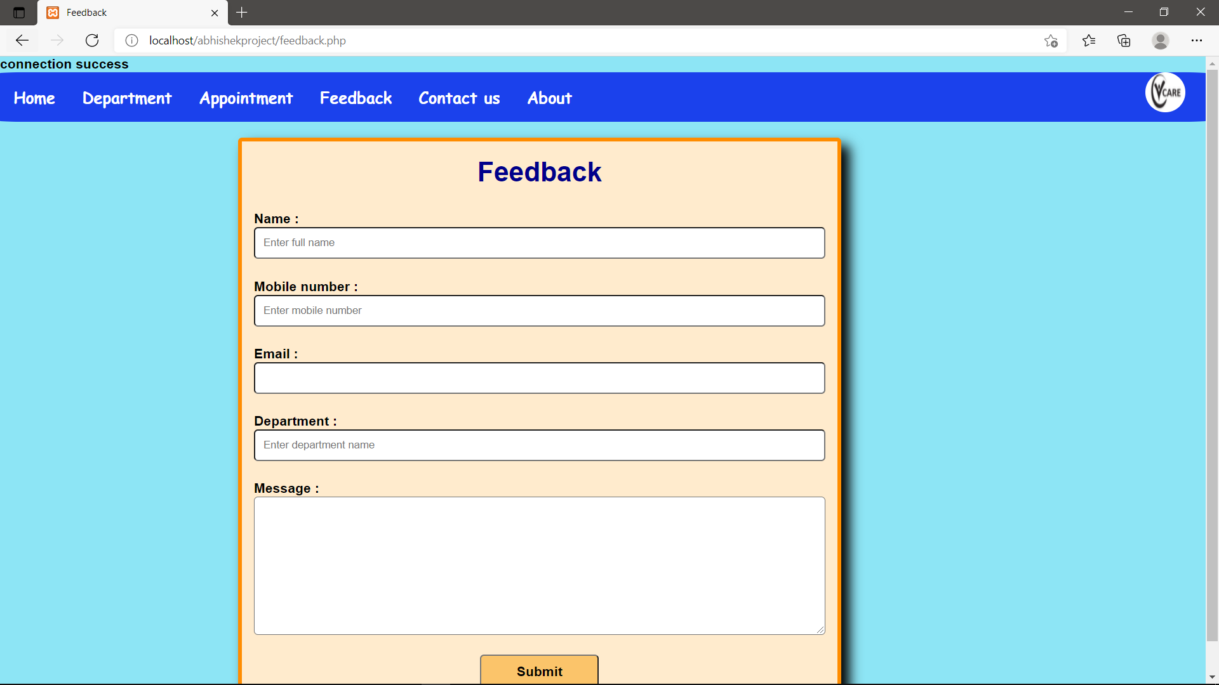

**CONTACT US**

**HTML:**

<!DOCTYPE html>

<html lang="en">

  <head>

    <meta charset="UTF-8" />

    <meta http-equiv="X-UA-Compatible" content="IE=edge" />

    <meta name="viewport" content="width=device-width, initial-scale=1.0" />

    <title>Contact Us</title>

    <link rel="stylesheet" href="contact.css">

    <link rel="preconnect" href="https://fonts.googleapis.com" />

    <link rel="preconnect" href="https://fonts.gstatic.com" crossorigin />

    <link

      href="https://fonts.googleapis.com/css2?family=Montserrat:wght@200&display=swap"

      rel="stylesheet"

    />

  </head>

  <body>

    <div>

      <img class="logo">

  <ul class="nav-bar">

      <li><a class="home" href="home.html">Home</a> </li>

      <li class="dipart">Department

      <div class="sub-list">

          <ul>

              <li><a href="cardiology.html">Cardiologist</a></li>

              <li><a href="orthopedic.html">Orthopedic</a></li>

              <li><a href="neurology.html">Neurologists</a></li>

              <li><a href="nephrology.html">Nephrologists</a></li>

              <li><a href="dentist.html">Densist</a></li>

              <li><a href="eyecare.html">Eye-care</a></li>

              <li><a href="genral.html">General</a></li>

          </ul>

      </div>

  </li>

  <li><a class="apoint" href="http://localhost/abhishekproject/project.php">Appointment</a></li>

  <li><a class="make" href="http://localhost/abhishekproject/feedback.php">Feedback</a></li>

  <li><a class="contact" href="contact.html">Contact us</a></li>

  <li><a class="about" href="about.html">About</a></li>

  </ul>

</div>

    <div>

      <img src="image/contact.png" alt="heading" />

    </div>

    <div id="line">

      <h1 id="heading">Contact us</h1>

      <p id="para">We are very happy to help you.</p>

    </div>

    <div id="container">

      <div class="items">

        <img src="image/email.png" alt="" />

        <h5>newlife69@gmail.com</h5>

      </div>

      <div class="items">

        <img src="image/phone.png" alt="" />

        <h5>8872564587 , 9878563457</h5>

      </div>

      <div class="items">

        <img src="image/address.png" alt="" />

        <h5>Green Park-159 , Mohali</h5>

      </div>

    </div>

  </body>

</html>

**CSS:**

* {

    padding: 0px;

    margin: 0px;

  }

  body{

    background-image: url("image/map.jpg");

    background-position: center;

    position: relative;

    background-size: cover;

    background-attachment: fixed;

}

  img {

    float: right;

    height: auto;

    width: auto;

    filter: drop-shadow(5px 5px 5px gray);

  }

  #heading {

    font-family: "Montserrat", sans-serif;

    color: white;

    margin-left: 50px;

    font-size: 60px;

  }

  #line {

    border-left: 5px solid white;

    height: 210px;

    margin: 0px 50px;

    margin-top: 50px;

  }

  #para {

    color: white;

    font-family: "Montserrat", sans-serif;

    margin-left: 50px;

    margin-top: 10px;

    font-size: 40px;

  }

  h3,

  h5 {

    font-family: "Montserrat", sans-serif;

    color: white;

    margin-left: 50px;

    margin-top: 10px;

  }

  #container {

    display: flex;

    margin-top: 180px;

    justify-content: space-evenly;

  }

  .items img {

    height: 150px;

    width: 150px;

    display: block;

    margin: auto;

    filter: invert(100%);

  }

  h5 {

    font-size: 20px;

    margin: 5px -48px;

    margin-top: 165px;

  }

/*   div img.logo{

  position:absolute;

  left: 95%;

  border-radius: 50%;

} */

  ul{

  display:inline-flex;

  background-color:rgba(14, 47, 235, 0.897);

  list-style: none;

  color: white;

  font-weight: bold;

  width: 100%;

  border-radius: 2%;

  /* position:fixed; */

}

li{

  padding: 15px;

  margin: 2px;

}

  ul.nav-bar a{

  color: white;

  font-family: cursive;

  text-decoration: none;

  font-weight: bold;

  font-size: 20px;

}

.dipart{

  color: white;

  font-family: cursive;

  text-decoration: none;

  font-weight: bold;

  font-size: 20px;

}

.dipart:hover{

  color: lawngreen;

  font-family: cursive;

  font-weight: bold;

  color: white;

  text-shadow: 0px 0px 30px rgb(0, 4, 255);

  font-size: 25px;

}

.dipart:hover .sub-list{

  display: block;

  position:absolute;

  padding: 1px;

  margin: 0;

}

.dipart:hover .sub-list ul{

  display: block;

  background-color: rgb(8, 8, 211);

}

.dipart:hover .sub-list ul li{

width: 150px;

background-position: center;

padding: 10px;

border-bottom: 1px dotted white;

background: transparent;

text-align: left;

}

.dipart:hover .sub-list ul li:last-child{

  border-bottom: none;

}

.dipart:hover .sub-list ul li:hover{

  color: rgb(3, 7, 255);

}

div img.logo{

  position:absolute;

  left: 95%;

  border-radius: 50%;

}

ul li div.sub-list{

display: none;

}

.dipart:hover h1.welcome{

display: none;

}

ul.nav-bar a:hover{

  color: lime;

}

/* div.homepage img{

  height: 230px;

  width: 230px;

  margin: 30px;

} */

**OUTPUT:**



**ABOUT US**

**HTML:**

<!DOCTYPE html>

<html lang="en">

  <head>

    <meta charset="UTF-8" />

    <meta http-equiv="X-UA-Compatible" content="IE=edge" />

    <meta name="viewport" content="width=device-width, initial-scale=1.0" />

    <link rel="preconnect" href="https://fonts.googleapis.com" />

    <link rel="preconnect" href="https://fonts.gstatic.com" crossorigin />

    <link

      href="https://fonts.googleapis.com/css2?family=Ubuntu:ital,wght@0,500;1,700&display=swap"

      rel="stylesheet"

    />

    <title>About us</title>

    <link rel="stylesheet" href="about.css">

  </head>

  <body>

    <div>

      <img class="logo" src="image/vcare2.png" alt="went wrong" width="50px" height="50px">

  <ul class="nav-bar">

      <li><a class="home" href="home.html">Home</a> </li>

      <li class="dipart">Department

      <div class="sub-list">

          <ul>

            <li><a href="cardiology.html">Cardiologist</a></li>

            <li><a href="orthopedic.html">Orthopedic</a></li>

            <li><a href="neurology.html">Neurologists</a></li>

            <li><a href="nephrology.html">Nephrologists</a></li>

            <li><a href="dentist.html">densist</a></li>

            <li><a href="eyecare.html">Eye-care</a></li>

            <li><a href="genral.html">General</a></li>

          </ul>

      </div>

  </li>

  <li><a class="apoint" href="http://localhost/abhishekproject/project.php">Appointment</a></li>

  <li><a class="make" href="http://localhost/abhishekproject/feedback.php">Feedback</a></li>

  <li><a class="contact" href="#">Contact us</a></li>

  <li><a class="about" href="about.html">About</a></li>

  </ul>

</div >

    <div class="line">

      <h1 id="pheading">About Us</h1>

      <div class="slogan">

      <p>:-WE CARE FOR YOU</p>

      <p>:-BETTER FOR YOU</p>

      <p>:-BY YOUR SIDE</p>

      <p>:-PROUD TO CARE</p>

      <p>:-THE HEART OF HEALTHCARE</p>

    </div>

      <p class="para">

        We are the physical execution of one of the pillars that form the

        infrastructure of a nation: healthcare.

      </p>

      <p class="para">

        Today,we are playing an increasingly important role in people’s lives;

        with great pollution levels and changing lifestyles, more and more

        people are falling prey to diseases and requiring adequate medical care.

      </p>

      <p class="para">And here we come to play our role.</p>

      <div>

        <img src="image/Doctor.png" alt="" />

      </div>

    </div>

    <h1>Creators</h1>

    <div id="creator">

      <div class="items">

        <img src="image/dev.png" alt="" />

        <p>Name:- Rajat Kalotra</p>

        <p>UIDS:- 20BCS4878</p>

      </div>

      <div class="items">

        <img src="image/dev.png" alt="" />

        <p>Name:- Abhishek Singh</p>

        <p>UIDS:- 20BCS4891</p>

      </div>

      <div class="items">

        <img src="image/dev.png" alt="" />

        <p>Name:- Ritik Athilkar</p>

        <p>UIDS:- 20BCS4872</p>

      </div>

      <div class="items">

        <img src="image/dev.png" alt="" />

        <p>Name:- Mohammad Tafhimul Hoque Alvee</p>

        <p>UIDS:- 20BCS4863</p>

      </div>

    </div>

    <footer>

      <div id="futer">

        <p id="end_para">Thank you</p>

      </div>

    </footer>

  </body>

</html>

**CSS:**

* {

    margin: 0px;

    padding: 0px;

  }

  body {

    background-image: url("image/hos.jpg");

    background-size: cover;

    background-attachment: fixed;

  }

  .line {

    border-left: 5px solid white;

    height: 650px;

    margin: 30px 50px;

  }

  #pheading {

    color: white;

    margin: 15px 50px;

    font-size: 50px;

    font-family: "Ubuntu", sans-serif;

  }

  div.slogan {

    margin-left: 64px;

    font-family: "Ubuntu", sans-serif;

    color: white;

  }

  .para {

    font-family: "Ubuntu", sans-serif;

    margin-left: 50px;

    margin-right: 820px;

    margin-top: 15px;

    color: white;

    font-size: 18px;

  }

  div img {

    height: 236px;

    width: 236px;

    margin-left: 50px;

    filter: drop-shadow(5px 5px 10px black);

  }

  #creator {

    /* border: 2px solid black; */

    display: flex;

    justify-content: space-evenly;

    align-items: center;

  }

  h1 {

    color: white;

    margin: 15px 122px;

    font-size: 50px;

    font-family: "Ubuntu", sans-serif;

  }

  .items {

    align-items: center;

    text-align: center;

    font-family: "Ubuntu", sans-serif;

    color: white;

    font-weight: bold;

    font-size: 15px;

    transition: transform 300ms, boxshadow 300ms;

    padding: 10px 10px;

  }

  .items:hover {

    border: 2px solid white;

    transform: scale(1.1);

    box-shadow: 0px 0px 5px 2px rgba(255, 255, 255, 0.75);

  }

  .items img {

    margin-left: 0px;

    height: 60px;

    width: 60px;

    filter: invert(100%);

  }

  #futer {

    margin-top: 20px;

    padding: 5px;

    font-family: "Ubuntu", sans-serif;

    color: white;

    background-color: #46a8ea;

    box-shadow: 0px -10px 3px #46a8ea;

  }

  #end_para {

    text-align: center;

  }

  ul{

    display:inline-flex;

    background-color:rgba(14, 47, 235, 0.897);

    list-style: none;

    color: white;

    font-weight: bold;

    width: 100%;

    border-radius: 2%;

}

li{

    padding: 15px;

    margin: 2px;

}

ul.nav-bar a{

    color: white;

    font-family: cursive;

    text-decoration: none;

    font-weight: bold;

    font-size: 20px;

}

.dipart{

    color: white;

    font-family: cursive;

    text-decoration: none;

    font-weight: bold;

    font-size: 20px;

}

.dipart:hover{

    color: lawngreen;

    font-family: cursive;

    font-weight: bold;

    color: white;

    text-shadow: 0px 0px 30px rgb(0, 4, 255);

    font-size: 25px;

}

.dipart:hover .sub-list{

    display: block;

    position:absolute;

    padding: 1px;

    margin: 0;

}

.dipart:hover .sub-list ul{

    display: block;

    background-color: rgb(8, 8, 211);

}

.dipart:hover .sub-list ul li{

width: 150px;

background-position: center;

padding: 10px;

border-bottom: 1px dotted white;

background: transparent;

text-align: left;

}

.dipart:hover .sub-list ul li:last-child{

    border-bottom: none;

}

.dipart:hover .sub-list ul li:hover{

    color: rgb(3, 7, 255);

}

div img.logo{

    position:absolute;

    left: 95%;

    border-radius: 50%;

}

ul li div.sub-list{

display: none;

}

.dipart:hover h1.welcome{

display: none;

}

ul.nav-bar a:hover{

    color: lime;

}

div.homepage img{

    height: 230px;

    width: 230px;

    margin: 30px;

}

**OUTPUT:**

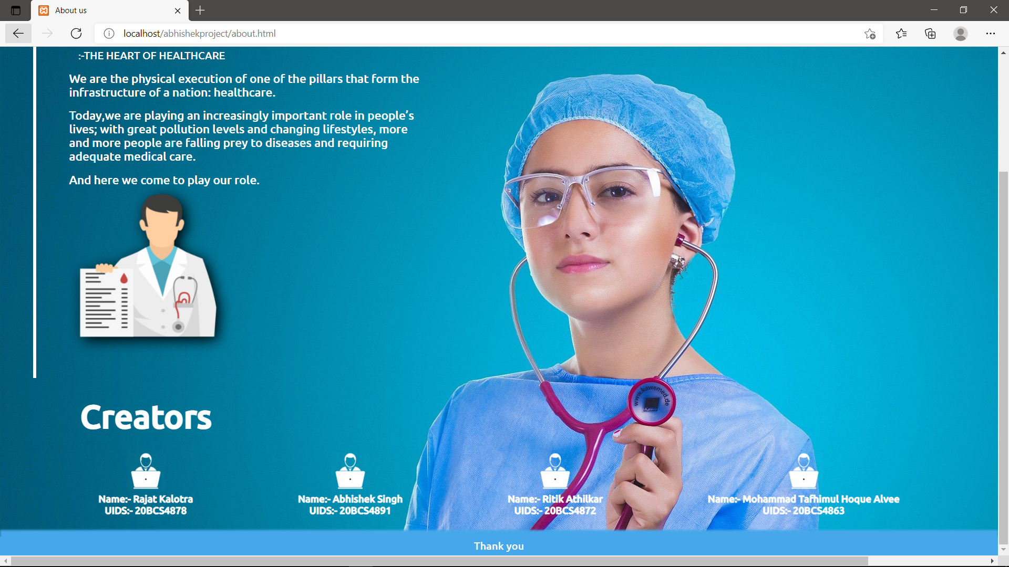

**4) CONCLUSION AND FUTURE SCOPE**

**4.1) FUTURE SCOPE:**

* Daily functions like patient registration, monitoring blood bank, managing admission and overall management of various departments can be easily performed with higher accuracy after the installation of [hospital software](http://www.hospitalerpsoftware.in/).
* The modules of hospital management software are user-friendly and easy to access. It has a common user friendly interface having several modules. The officials can utilize these modules in their processes without any hassle and make the best possible use of hospital management system.
* Since, every hospital has some or the other points of worth those vary in comparison with to its competitors. Hence, most of the IT companies give on-demand solutions or feature of customization. It further implicates that hospital information management software can be customized by specifying personal requirements of the campus.
* The automated functions of [online hospital software](http://www.hospitalerpsoftware.in/) make productivity effective. This web based IT solution has automated operations and permit officials to continue with their work in a swift manner. It further implicates that complete automation of the hospital software makes productivity easily obtainable. All in all, this enhances the infrastructure of hospital administration.

**4.2) CONCLUSION:**

We can conclude that our hospital website is Quite Useful To Us In many ways. Everyone needs to be well informed and concerned about the quality of care. *Everyone* means patients and their families, consumer agents and advocates, health professionals, administrators of health plans and facilities, purchasers of health care services, and policymakers at all levels. The messages to these audiences are:-

1. Quality of care can be measured and improved.
2. Quality of care should not be ignored in pursuit of cost control. Reinforcing these messages means making sure that quality of care stays on the health care-delivery agenda, with clear identification of the risks and opportunities that are posed by the changes in health care in the United States. It also means describing how health plans, health care organizations, and clinicians should be accountable to patients and society and, conversely, how individuals can take appropriate responsibility for their own health.

**4.3) REFERENCES:**

1. ^[*"Hospitals"*](https://www.who.int/hospitals/en/). World Health Organization*. Retrieved*24 January*2018*.
2. ^ [Jump up to:***a***](https://en.wikipedia.org/wiki/Hospital#cite_ref-bbc1_2-0) [***b***](https://en.wikipedia.org/wiki/Hospital#cite_ref-bbc1_2-1) [***c***](https://en.wikipedia.org/wiki/Hospital#cite_ref-bbc1_2-2) [*"India's 'production line' heart hospital"*](https://www.bbc.co.uk/news/health-10830889). bbcnews.com. 1 August 2010*. Retrieved*13 October*2013*.
3. [**^**](https://en.wikipedia.org/wiki/Hospital#cite_ref-4) Lovoll, Odd (1998). A Portrait of Norwegian Americans Today. U of Minnesota Press. p. 192. [*ISBN*](https://en.wikipedia.org/wiki/ISBN_(identifier)) [*978-0-8166-2832-2*](https://en.wikipedia.org/wiki/Special:BookSources/978-0-8166-2832-2).
4. [**^**](https://en.wikipedia.org/wiki/Hospital#cite_ref-5) *Cassell's Latin Dictionary*, revised by J. Marchant & J. Charles, 260th. thousand.
5. ^ [*"Our Background"*](https://web.archive.org/web/20140714153446/http:/www.cadhlf.org/about-dhlf/our-background/). District Hospital Leadership Forum. Archived from [*the original*](http://www.cadhlf.org/about-dhlf/our-background/) on 14 July 2014*. Retrieved*10 July*2014*.